**Institute of Technology Tralee**

**Computing Department**

**Lab 3 Layer 7 Applications - FTP**

The purpose of this practical is as follows:

To give you the opportunity of learning and using the**File Transfer Protocol** (FTP). You will see how FTP can be used in

1] a non-GUI environment i.e. at the command line prompt,

2] with a dedicated FTP client (software application) like CuteFTP or FileZilla and

3] from a web browser such as Windows Internet Explorer.

## **What is FTP?**

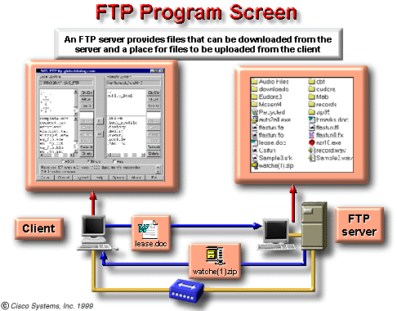

The **File Transfer Protocol** (FTP) is one that is used by millions of people on a daily basis in order to transfer files from one location to another on the internet or on an intranet. The utility is especially suited for the fast downloading of upgrades and software drivers and hence is much used by network administrators who can’t afford to wait a few days to receive such software from the vendor. At the application layer of the TCP/IP model there are a number of protocols, one of which is **FTP**.

*FTP* is a client-server application just like e-mail and ***Telnet***. *FTP* requires server software, running on a host that is accessible by client software.

Practical Work

### Ordinary & Anonymous FTP Sessions

There are various implementations of the FTP protocol available.

In order for you to be able to connect to a remote machine for file transfer purposes you need to be able to first of all log on to that machine. In other words, you must have a **username/password** combination in order to proceed. If the remote machine is configured as an FTP server then you will be able to supply the machine name and then your username/password for that machine (the remote machine assumes you have an account on it – if you don’t then trying to connect will prove fruitless). This kind of FTP session would be considered **ordinary** and simply means that most people cannot actually access the files on the remote machine.

However, machines that act as FTP servers can use what is called **anonymous FTP** so that clients who wish to connect to them can simply provide an "anonymous" username/password combination and this means that anyone can log on.

**1] FTP from the command prompt - A step back in time**

People still use the command-line in order to carry out an FTP session, some out of habit, some because they have no choice e.g. they might be network administrators using Linux/UNIX server machines that only have the OS installed with no GUI desktop environment – this is quite normal. People working in such environments need to be conversant in the native OS at the command line and in this case, need to be able to use FTP commands at the command line in order to upload/retrieve file(s).

Complete the following exercise in order to retrieve a file from the ftp.heanet.ie server using only command line instructions only. This FTP site is administered by the Higher Education Authority.

Launch command prompt from within Windows XP/Win 7. At the command prompt create a new folder for yourself as follows:

C: cd.. (this will move you up a level)

then

cd students (change directory to the students folder on the C: drive)

md HEA_Stuff (make a directory/folder called HEA_Stuff)

Now change into this folder as follows:

cd HEA_Stuff

Now try to connect to the HEAnet FTP server as follows:

ftp ftp.heanet.ie

At this stage you should be prompted for your username/password combination as indicated below:

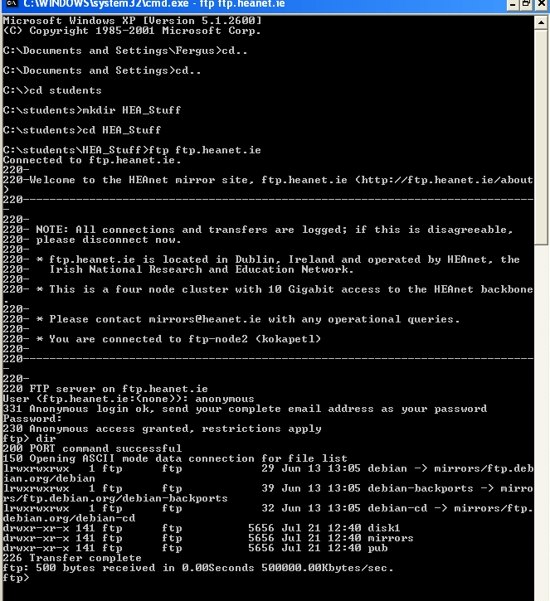

You should enter *anonymous* as your username and your password should be something that resembles an e-mail address e.g. me@itt – note the characters of your password will not be echoed to the screen.

You should now receive a welcome message.

First of all you need to know how to navigate your way around the FTP server. Just type

dir to list all the files and folders that resides in the current working directory (cwd).

One of the folders listed should be pub (refers to public access area).

Type ? to get a list of the ftp command line commands.

Change into the pub folder by typing

cd pub

and list its contents. Now change into the vim folder and list its contents.

Now change into the stuff folder and list its contents.

You will now see a file called *20060919_BOF.wav* in the list. You now want to retrieve that file to your local machine. To do this type:

binary

to change to a binary file type instead of the default ASCII file type

then type

get *20060919_BOF.wav*

and you should have the file in your current directory on your local drive.

Now just check to see if the file has actually been transferred okay by using your find tool in Windows. You can see below that the file has been copied to my C:\students\HEA_Stuff folder.

As an exercise now, see if you can copy across multiple files at the command line (the command here is mget as in multiple get). Also see if you can upload a file to the FTP server (can you think why you might have a problem doing this? In any case the commands are put and mput).

Finally, to break the FTP connection smoothly from Command prompt you can just issue the following command:

bye

##### Making an Ordinary FTP Connection using a FTP Client

#### The FTP client application we are going to use is Filezilla – this is a free opensource download. Download the latest **client version** of this application from the internet, install it and launch the application.

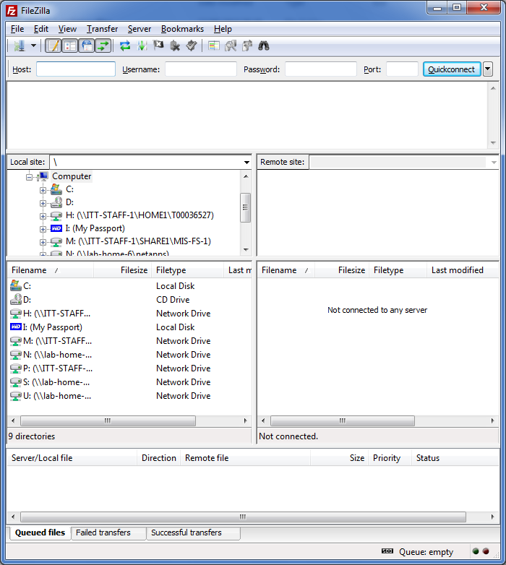

The window indicates that you are **"not connected"** to any remote machine at present as there are no files listed in the right pane.

This window is your gateway to the remote machine and you need to supply information about the machine you are connecting to along with your username and password information. Try making an anonymous connection to ftp.heanet.ie site. Supply the username and password as before and then click on the *Quickconnect* button positioned just after the Port 21 textbox.

Navigation is now obviously much easier. Locate any files of interest and simple drag them to your C:\students folder and keep them. Try uploading a file.

Ordinary FTP connection

There are numerous FTP sites on the internet and some allow you to store your files on their server for free or to host your web pages. One such site is ftp.adrive.com. I have created an account with my own password and username and this time you will log on as normal/ordinary.

The username is **fergus.mclysaght@ittralee.ie** and the password is **Ittralee12345**

Note that the "password" information will not be displayed for security reasons but will be displayed instead as a series of asterisks (*).

You will see folders up on the FTP server including one called *Summer Exams* which contains you your final exam so it may be worth your while downloading it!!!!

Note you can access your files using HTTP via the Web Browser or FTP using an FTP client such as Filezilla.

**Exercise 1:**

You should now create a folder under your own name on the FTP server machine at the same level as my **fergus** folder. You should select a small file on your local machine and attempt to **upload** it to your own newly created folder on the server.

**Exercise 2:**

Files stored on the adtive.com ftp server account are also accessible through your web browser using **http**. Create your own account on adrive.com and see can you upload and download files to your account using both the web-based interface and the ftp client Filezilla.

Create a 60 day trial account on adrive.com

FTP over a Web browser

Now we are going to use a Web Browser such as Mozilla or Internet Explorer to get a file from a FTP server on the Internet. Mozilla offers better support for FTP over IE so use Mozilla.

Launch your browser and in the Location (URL) box remove the current contents and type in ftp://ftp.heanet.ie/. Your browser should then look as follows,

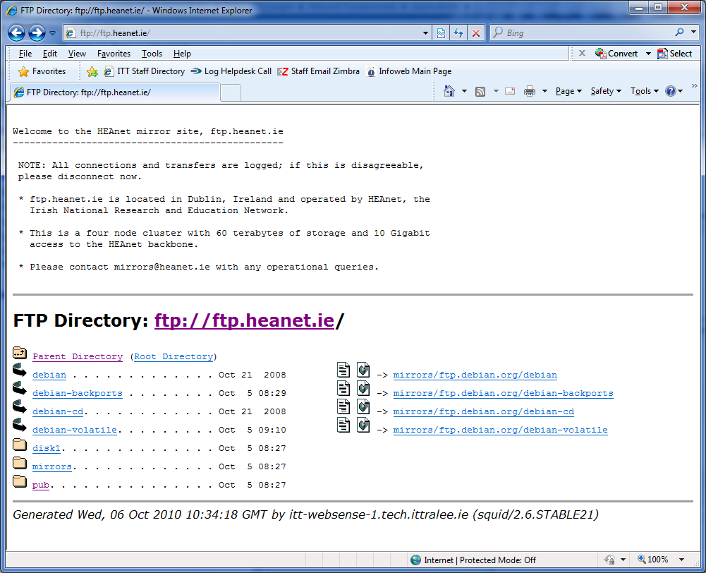

Navigate your way around the different folders and examine all the software that is free to download. If you wish you can select the *Open FTP site in Windows Explorer* option on the View menu and the site will open in Windows Explorer.

If you wish you can also access the FTP server from Windows Explorer.

You can access the ftp.adrive.com server via the web browser in the same manner.

In Win 7 you need to map the remote site as a network drive. Open Windows Explorer and right click on the Network icon and choose Map Network drive.

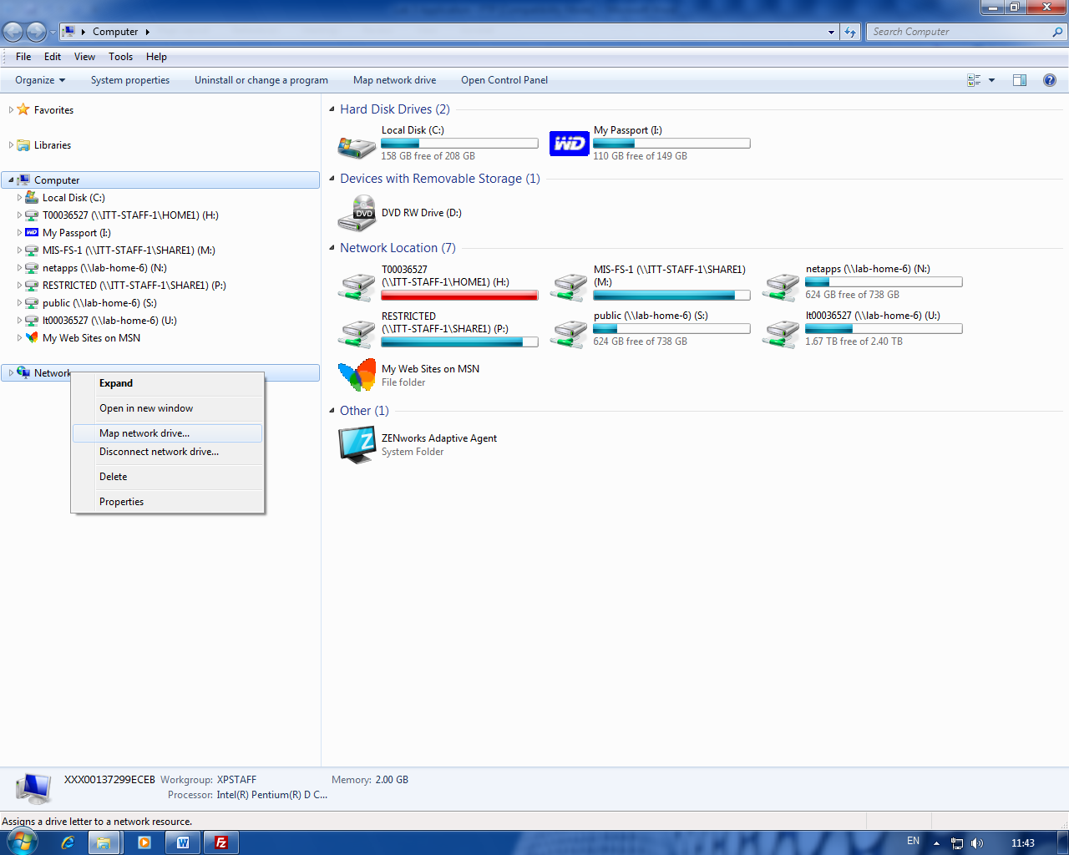

Select the link to “Connect to a Web site ….” and follow the wizard instructions.

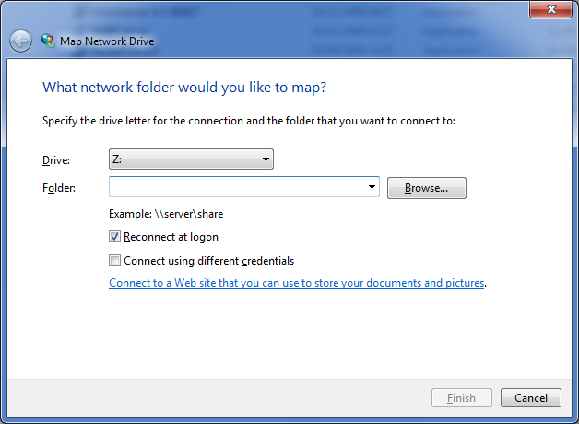

The networked FTP server will appear in your listing of drives under windows explorer when you have completed the task.

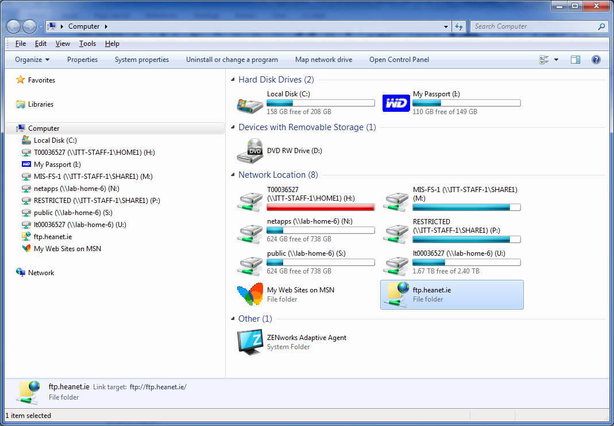

**Exercise:**

Access this you adrive.com ftp server file from your own home computer.